A Service of Remembrance

St Mary Newington

Friday 15th October 2021, 7pm

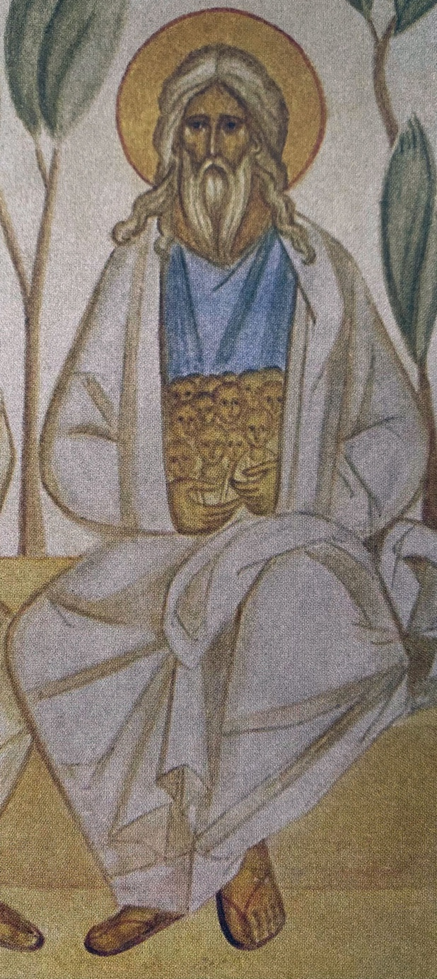

Image: Abraham with the souls of the righteous in his bosom.
Fresco detail from the Chapel of All Saints Community of St John the Baptist (Essex, England)

Baby Loss Awareness Week is held annually from 9 to 15 October. It’s a special opportunity to mark the lives of babies lost in pregnancy or at or soon after birth.

On 15th October, people around the world light a candle or candles at 7pm local time in memory of the baby or babies they have lost.

We gather at St Mary’s to mark this occasion with a short service of remembrance and to light candles together. We extend an invitation to anyone who has been affected by miscarriage, still birth or the loss of a child, at whatever age; to those who struggle with infertility; to those who long for children; and to those who have made the difficult decision to end a pregnancy.

Welcome

We gather here in grief and pain. In this moment there is no understanding, only the emptiness of sorrow, loss and dreams unfulfilled. We are overwhelmed by the mystery of life and death that we have experienced. Yet we remember, in our confusion and distress, that the eternal God is here, the One whose love is seen in Jesus Christ.

Without Ceremony by Vassar Miller, read by Alison McKenna
Except ourselves, we have no other prayer;
Our needs are sores upon our nakedness.
We do not have to name them; we are here.
And You who can make eyes can see no less.
We fall, not on our knees, but on our hearts,
A posture humbler far and more downcast;
While Father Pain instructs us in the arts
Of praying, hunger is the worthiest fast.
We find ourselves where tongues cannot wage war
On silence (farther, mystics never flew)
But on the common wings of what we are,
Borne on the wings of what we bear, toward You,
Oh Word, in whom our wordiness dissolves,
When we have not a prayer except ourselves.
Vassar Miller (1937–1998) was a writer and poet. She served as Poet Laureate of Texas (1988-1989). Miller was born with cerebral palsy and her poetry explores religious faith, social isolation, and physical disability.

Reflection: Every lament is a love-song, by Lucy Newman Cleeve

Readings and Meditation:
We cry out to God:
How long, O Lord? Will you forget me forever? How long will you hide your face from me? Must I bear this grief for ever, and have sorrow in my heart day after day?
Psalm 13:1-2
Silence
My God, my God, why have you forsaken me?
Why are you so far from helping me,
from the words of my groaning?
O my God, I cry by day, but you do not answer;
and by night, but find no rest.
Psalm 22:1-2
Silence
We hear again the promises of God:
The steadfast love of the Lord never ceases, God’s mercies never come to an end; they are new every morning, great is your faithfulness.
Lamentations 3:22-23
Silence
The Lord comforts his people and will have compassion on his afflicted ones.

Isaiah 49:13
Silence
For the mountains may depart
and the hills be removed,
but my steadfast love shall not depart from you,
and my covenant of peace shall not be removed,
says the Lord, who has compassion on you.

Isaiah 54:10
Silence
Blessed are the poor in spirit, for theirs is the kingdom of heaven. Blessed are those who mourn, for they will be comforted.
Matthew 5:3-4
Silence
Come to me, all you that are weary and whose load is heavy, and I will give you rest ... for I am gentle and humble in heart, and you will find rest for your souls.
Matthew 11:28-29
Silence

Prayers:
God of love,
We thank you for the assurance of your presence.
We thank you that you are with us in the storms
As well as by the still waters.
We come before you today to bring our grief
For the times of pain and tears;
Times of not being understood by family and friends,
Times of longing and struggling,
Times of searching and emptiness,
Times of giving up hope.
For the feelings of loss;
For the child we could never bring to birth,
For the child whose time with us was too short,
For all that we can never share with them.
O God, giver of all comfort, Hear our prayer.
God of compassion,
You make nothing in vain
And love all that you have created.
Look down on those who have known the joy of new life within
And the desolation of losing that life;
Do not hide your face from their distress,
But hear them when they call to you;
Restore them to health in body and spirit
And renew them in hope, faith and love.
O God, giver of all comfort, Hear our prayer.

We say together the Lord’s Prayer:
Our Father, who art in heaven,
hallowed be thy name;
thy kingdom come;
thy will be done;
on earth as it is in heaven.
Give us this day our daily bread.
And forgive us our trespasses,
as we forgive those who trespass against us.
And lead us not into temptation;
but deliver us from evil.
For thine is the kingdom,
the power and the glory,
for ever and ever.
Amen.

Lighting of the candles
We light a candle to express the longing of our hearts;
The longing for the gift of a child.
We light a candle to remember the child we dreamed about;
the thought of whom brought the promise of joy to our lives.
We light a candle to remember the child whose time with us was too short; who we yearn to hold again.
We light a candle to remember the child we gave up.
Enfold us and them in your mighty and eternal life of love.
God who sees into the depths of our hearts
And knows our words before we speak them,
We lay down the burden of our grief before you,
We lay down the sadness and the emptiness,
We also lay down our cherished memories and our love.
We release them into your transforming power
Trusting that you know us and love us.
We ask you to walk with us and to grant us healing and strength.

Please come forward to light a candle if you would like to or feel free to sit quietly and listen to the music.

Ave Verum Corpus  Ave verum corpus, natum  de Maria Virgine,  vere passum, immolatum  in cruce pro homine  cuius latus perforatum  fluxit aqua et sanguine:  esto nobis praegustatum  in mortis examine.  O Iesu dulcis, O Iesu pie,  O Iesu, fili Mariae.  Miserere mei. Amen | Hail, true Body, born  of the Virgin Mary,  having truly suffered, sacrificed  on the cross for mankind,  from whose pierced side  water and blood flowed:  Be for us a foretaste [of the Heavenly banquet]  in the trial of death!  O sweet Jesus, O holy Jesus,  O Jesus, son of Mary,  have mercy on me. Amen.
Wolfgang Amadeus Mozart 1791

O Lord Hear my Prayer  O Lord, hear my prayer,  O Lord, hear my prayer;  when I call answer me.  O Lord, hear my prayer,  O Lord, hear my prayer;  come and listen to me.  © 1982, Les Presses de Taizé | Within our Darkest Night  Within our darkest night,  You﻿ kindle the fire that never dies away,  That never dies away.  © 1991, Les Presses de Taizé

Reading:
Then I saw “a new heaven and a new earth,” for the first heaven and the first earth had passed away, and there was no longer any sea. I saw the Holy City, the new Jerusalem, coming down out of heaven from God, prepared as a bride beautifully dressed for her husband. And I heard a loud voice from the throne saying, “Look! God’s dwelling place is now among the people, and he will dwell with them. They will be his people, and God himself will be with them and be their God. ‘He will wipe every tear from their eyes. There will be no more death’ or mourning or crying or pain, for the old order of things has passed away.”
He who was seated on the throne said, “I am making everything new!” Then he said, “Write this down, for these words are trustworthy and true.”
He said to me: “It is done. I am the Alpha and the Omega, the Beginning and the End. To the thirsty I will give water without cost from the spring of the water of life.”
Revelation 21:1-6

Hymn: Abide with Me

Abide with me, fast falls the eventide
The darkness deepens Lord, with me abide
When other helpers fail and comforts flee
Help of the helpless, oh, abide with me.

Swift to its close ebbs out life's little day
Earth's joys grow dim, its glories pass away
Change and decay in all around I see
O Thou who changest not, abide with me.

Come not in terror, as the King of kings,
But kind and good, with healing in Thy wings;
Tears for all woes, a heart for every plea.
Come, Friend of sinners, thus abide with me.

I need Thy presence every passing hour.
What but Thy grace can foil the tempter's power?
Who, like Thyself, my guide and stay can be?
Through cloud and sunshine, Lord, abide with me.

I fear no foe, with Thee at hand to bless
Ills have no weight, and tears no bitterness
Where is death's sting? Where, grave, thy victory?
I triumph still, if Thou abide with me.

Hold Thou Thy cross before my closing eyes
Shine through the gloom and point me to the skies
Heaven's morning breaks, and earth's vain shadows flee
In life, in death, O Lord, abide with me.

Words: Henry Francis Lyte, 1847 / Music: ‘Eventide’ by William Henry Monk, 1861

Dismissal:
May the peace of God, which passes all understanding, keep our hearts and minds in the knowledge and love of God, and of his Son, Jesus Christ our Lord. And may the blessing of God Almighty, the Father, the Son and the Holy Spirit, be upon us and remain with us always.

Amen.

There will be a retiring collection in aid of the work of Petals, the baby loss counselling charity, offering free specialist counselling to women and partners who suffer psychological distress from trauma and grief related to pregnancy or baby loss.
https://petalscharity.org/

With thanks to our musicians:
Natalee Jeremic, Kim Bourlet, Abigail Rouch and Hannah Shield.

If you would like further support or prayer, please speak to us afterwards, or contact us via the church website: https://stmarynewington.church/contact-us/

For information of pregnancy and baby-loss organisations and general bereavement support, please visit:
https://babyloss-awareness.org/support/

Parts of this service were adapted from A Liturgy of Loss by Lizzie Lowry which can be found at http://saltwaterandhoney.org/
Saltwater and Honey is a collection of voices sharing their stories about infertility, miscarriage, childlessness and faith.

